# Lecture 54. VPC Overview 16:10

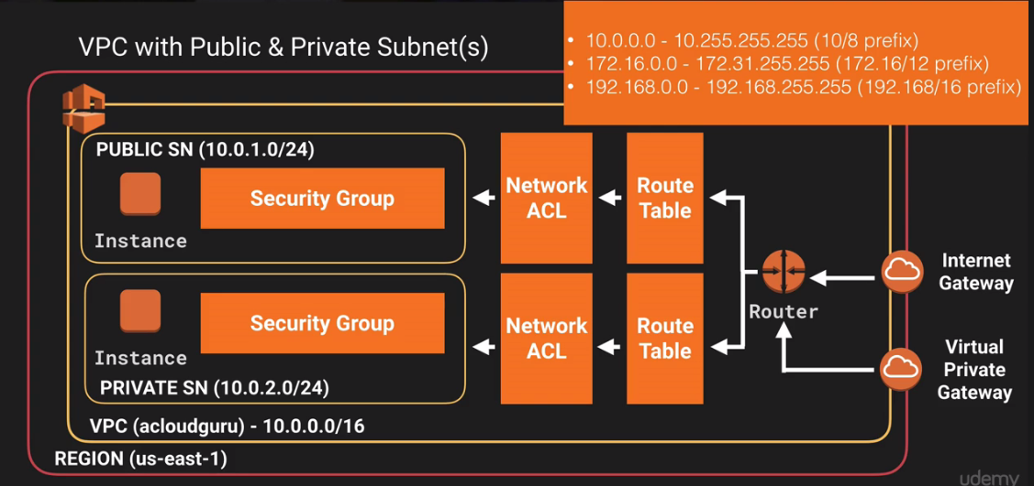

Note:

1. Subnet Cannot Span Multi-AZ
2. Security Group Can Span Multi-AZ
3. N/W ACL Can Span Multi-AZ
4. Route Table Can Span Multi-AZ

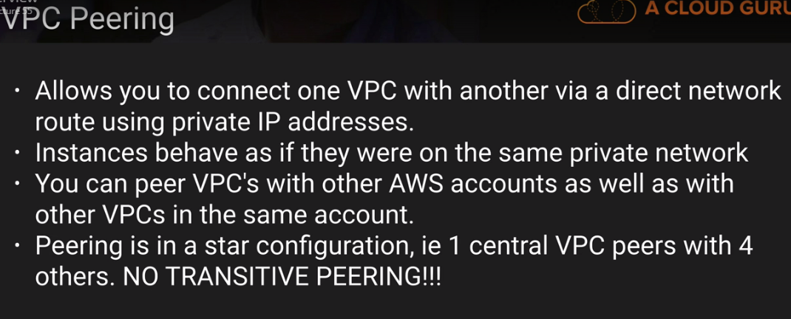

# Lecture 55. Build a custom VPC 19:53

# Lecture 56. Build A Custom VPC - Part 28:45

# Lecture 57. Network Address Translation (NAT)18:24

# Lecture 58. Access Control Lists (ACLs) 17:18

# Lecture 59. Custom VPC's and ELBs 2:30

# Lecture 60. NAT's vs Bastions 3:57

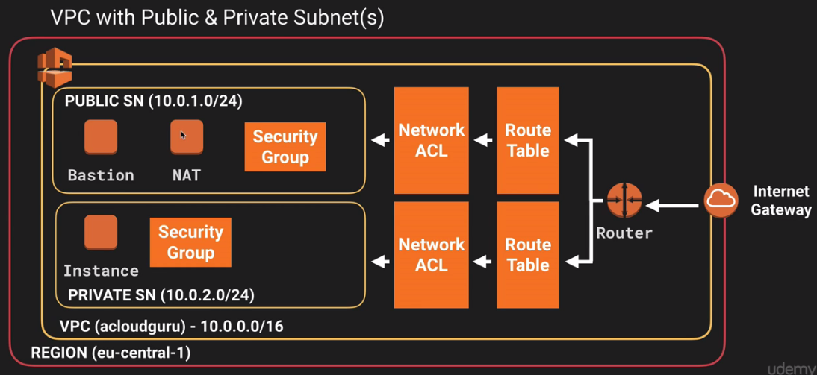

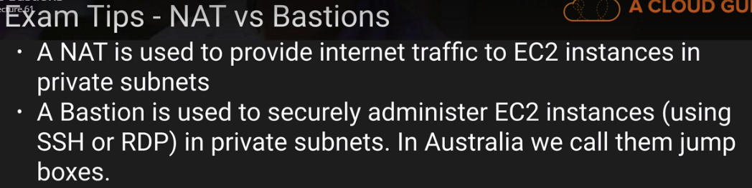

# Lecture 61. VPC Flow Logs 4:35

# Lecture 62. VPC Clean Up 5:11

# Lecture 63. VPC Summary 11:05

